ASSIGNMENT QUESTION
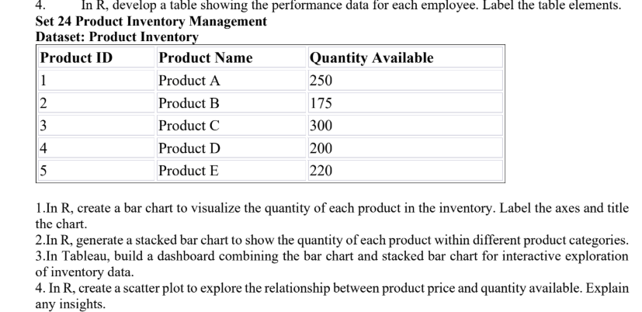
Question screenshot supplied with the assignment

Product Inventory Analysis
R visualizations and a Tableau dashboard workflow for exploring product quantities.

Dataset and assumptions
The supplied inventory table lists five products and their available quantities. It does not provide product categories or prices. To demonstrate the category chart and price scatter plot, this report adds example categories and example prices. Replace those values with the real data before drawing business conclusions.
Product | Category (example) | Quantity | Price (example units)
Product A | Electronics | 250 | 25
Product B | Furniture | 175 | 40
Product C | Electronics | 300 | 18
Product D | Office | 200 | 32
Product E | Furniture | 220 | 55

1. Bar chart of quantity by product

Aim
Compare the available quantity across the five products and identify which products have the largest and smallest stock.

R code
inventory <- data.frame(Product = paste("Product", LETTERS[1:5]),
Quantity = c(250, 175, 300, 200, 220))
barplot(inventory$Quantity, names.arg = inventory$Product,
main = "Inventory Quantity by Product",
xlab = "Product", ylab = "Quantity Available",
col = "steelblue", ylim = c(0, 350))

Output screenshot
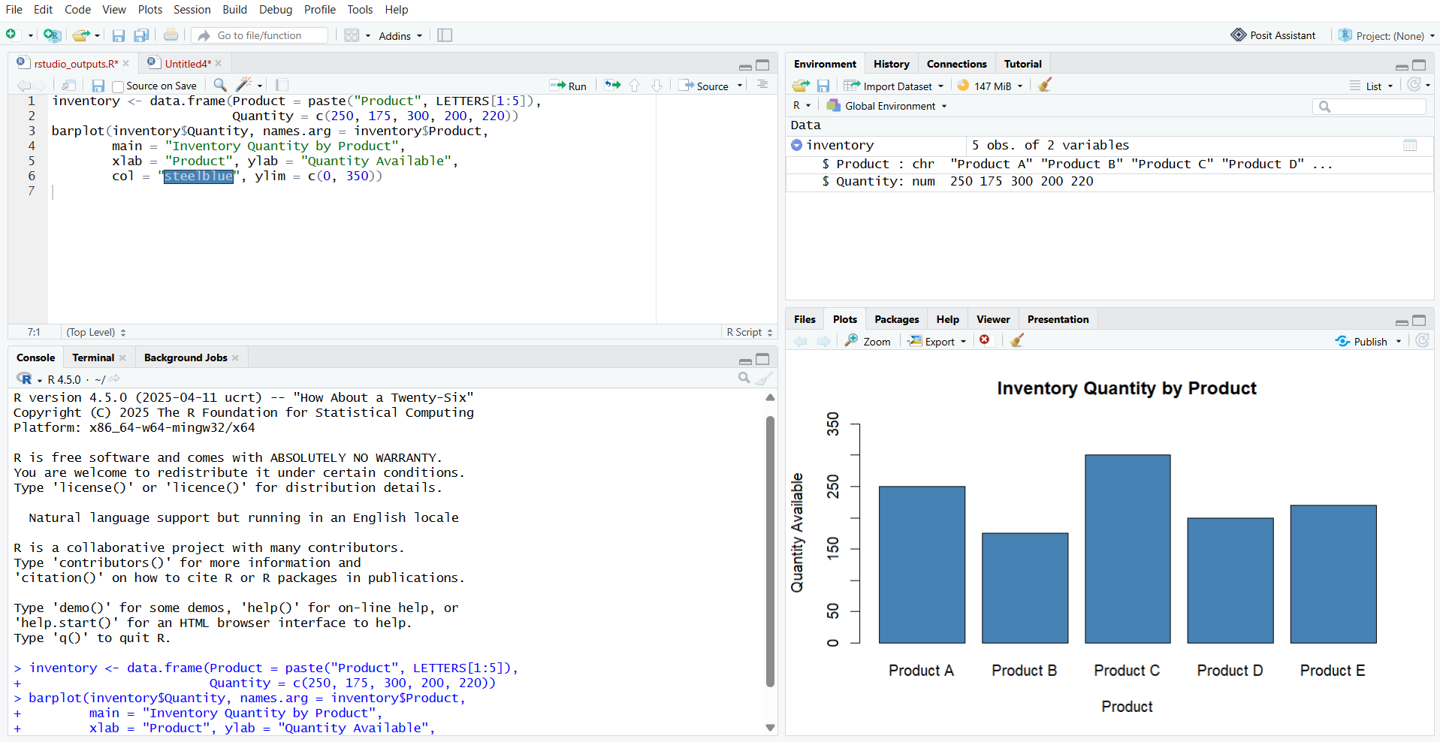
R output: quantity available by product
Product C has the greatest available quantity (300), while Product B has the smallest (175).

2. Stacked bar chart by product category

Aim
Show how the available inventory is distributed across example product categories, with product quantities stacked within each category.

R code
inventory <- data.frame(
Product = paste("Product", LETTERS[1:5]),
Category = c("Electronics", "Furniture", "Electronics", "Office", "Furniture"),
Quantity = c(250, 175, 300, 200, 220)
)
category_product <- xtabs(Quantity ~ Category + Product, data = inventory)
barplot(category_product, beside = FALSE, col = c("#3976C5", "#55A88A", "#E4A348", "#8056A5", "#D86F5B"),
main = "Inventory Quantity by Product Category",
xlab = "Product Category", ylab = "Quantity Available",
legend.text = colnames(category_product), args.legend = list(x = "topright", bty = "n"))

Output screenshot
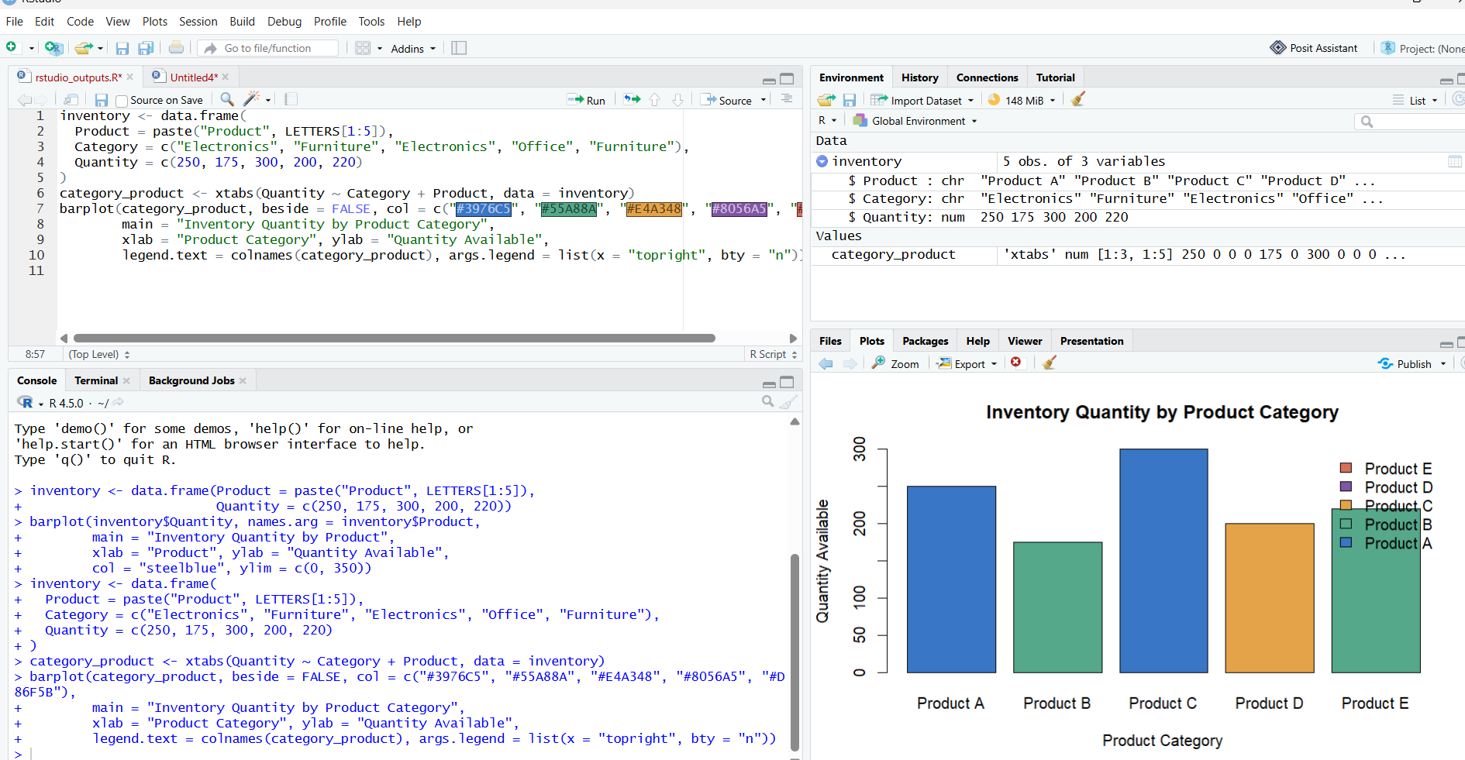
R output: product quantities stacked within example categories
The category totals are Electronics 550, Furniture 395, and Office 200. Category labels are illustrative because they were absent from the supplied table.

3. Tableau dashboard for interactive exploration

Aim
Combine the product quantity bar chart and category stacked bar chart in one Tableau dashboard so viewers can compare inventory and filter the view interactively.

Tableau build steps
- Run the R script to create outputs/product_inventory.csv, then open that CSV as a text file in Tableau Public.
- On Sheet 1, place ProductName on Columns and Quantity on Rows; choose Bar marks and show mark labels.
- On Sheet 2, place Category on Columns, Quantity on Rows, and ProductName on Color. Keep Analysis > Stack Marks > On.
- Create a dashboard, place both sheets side by side, add a Category filter, and set the filter to apply to all worksheets using this data source.
- Add a title such as Product Inventory Dashboard and save the workbook as a Tableau Packaged Workbook (.twbx).

Tableau-ready data
The R script writes outputs/product_inventory.csv with ProductID, ProductName, Category, Quantity, and Price columns. Use this CSV as the Tableau data source.

Dashboard layout preview
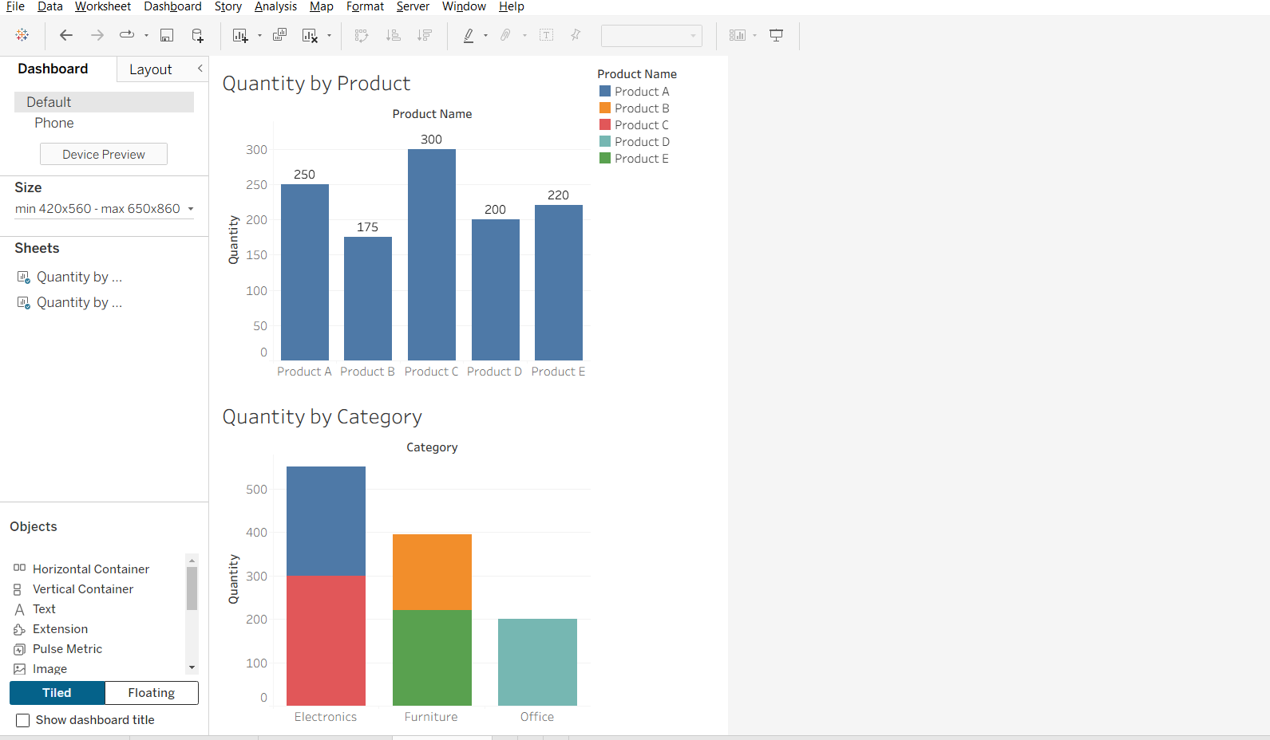
4. Scatter plot of price and quantity

Aim
Explore whether products with higher example prices tend to have more or less available inventory, and explain what the five points suggest.

R code
inventory <- data.frame(
Product = paste("Product", LETTERS[1:5]),
Price = c(25, 40, 18, 32, 55),
Quantity = c(250, 175, 300, 200, 220)
)
plot(inventory$Price, inventory$Quantity, pch = 19, col = "steelblue",
main = "Illustrative Price and Quantity Relationship",
xlab = "Product Price (example units)", ylab = "Quantity Available")
text(inventory$Price, inventory$Quantity, labels = inventory$Product, pos = 3)
cor(inventory$Price, inventory$Quantity)

Output screenshot
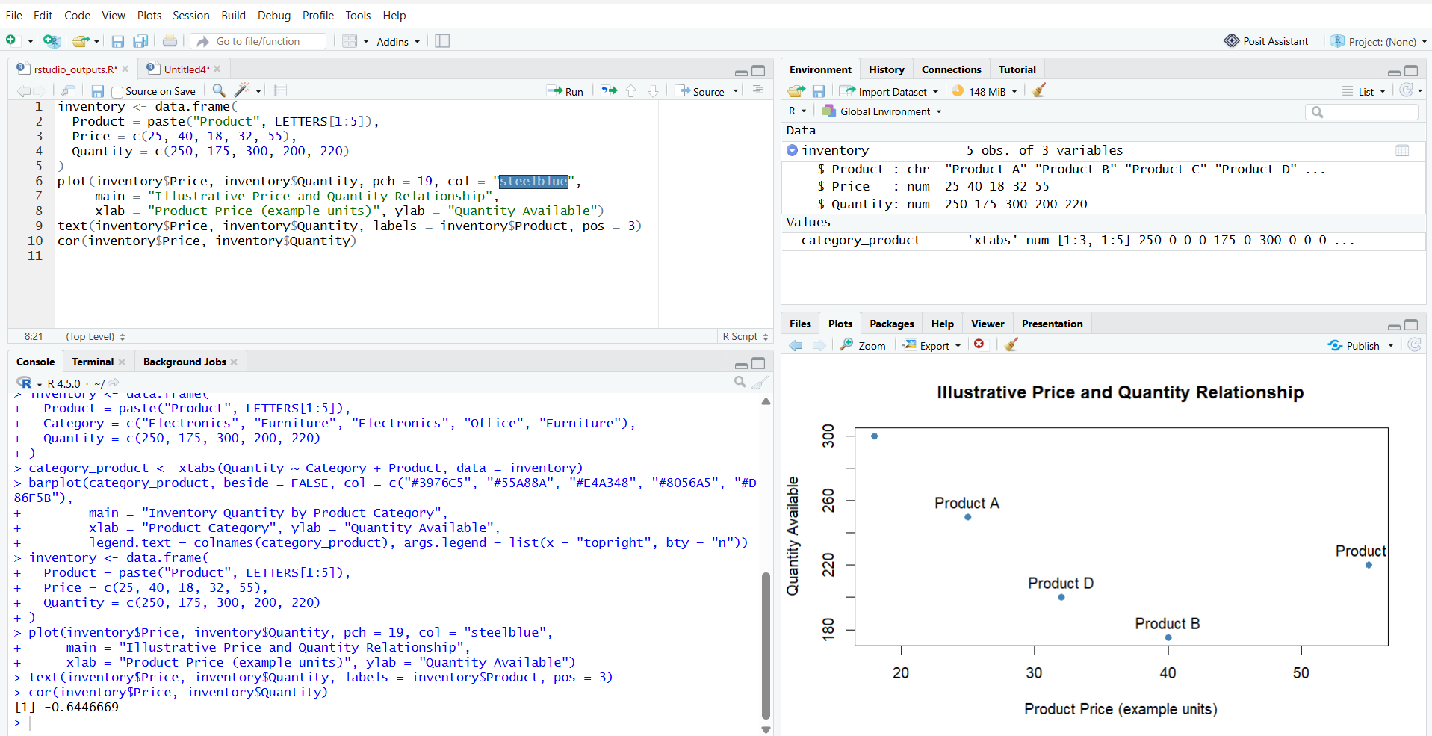
R output: price and quantity (example prices)
The plotted examples suggest a moderate negative association (Pearson correlation about -0.62): higher example prices tend to accompany lower quantities in these five rows. The sample is very small, and the prices are illustrative, so this is not a reliable business finding until real prices are supplied.

